**Category Name:** Media

**What is the category for?**

The media category is used to manage the media on your WordPress site. This media can vary from pictures, videos, and another graphics.

**How should it be used?**

You should use it to manage and store all your media files for your WordPress site so they are all in one place.

**How will you use it?**

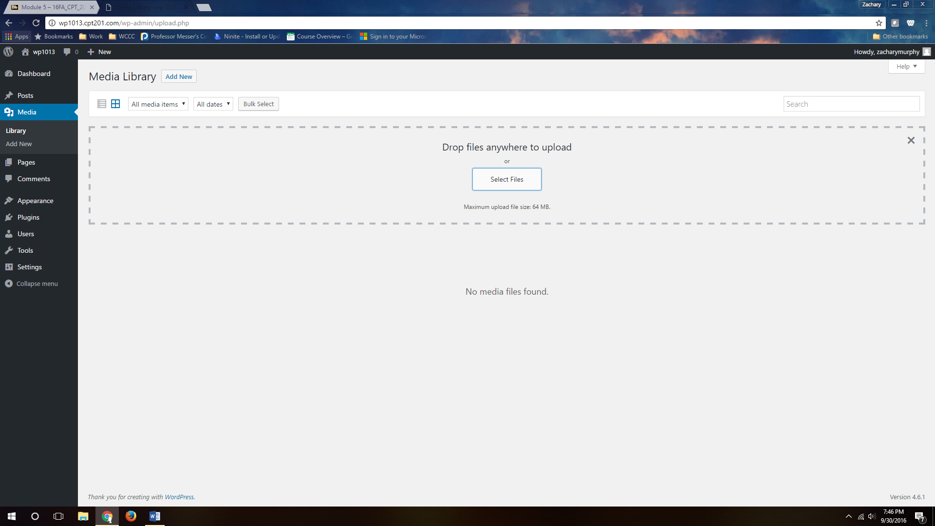

Once you click on the media tab on the left you can select Add New, once you do that you will click select files and a dialog box will come up allowing you to upload files from your PC. You can also just drag and drop them into the dotted area.

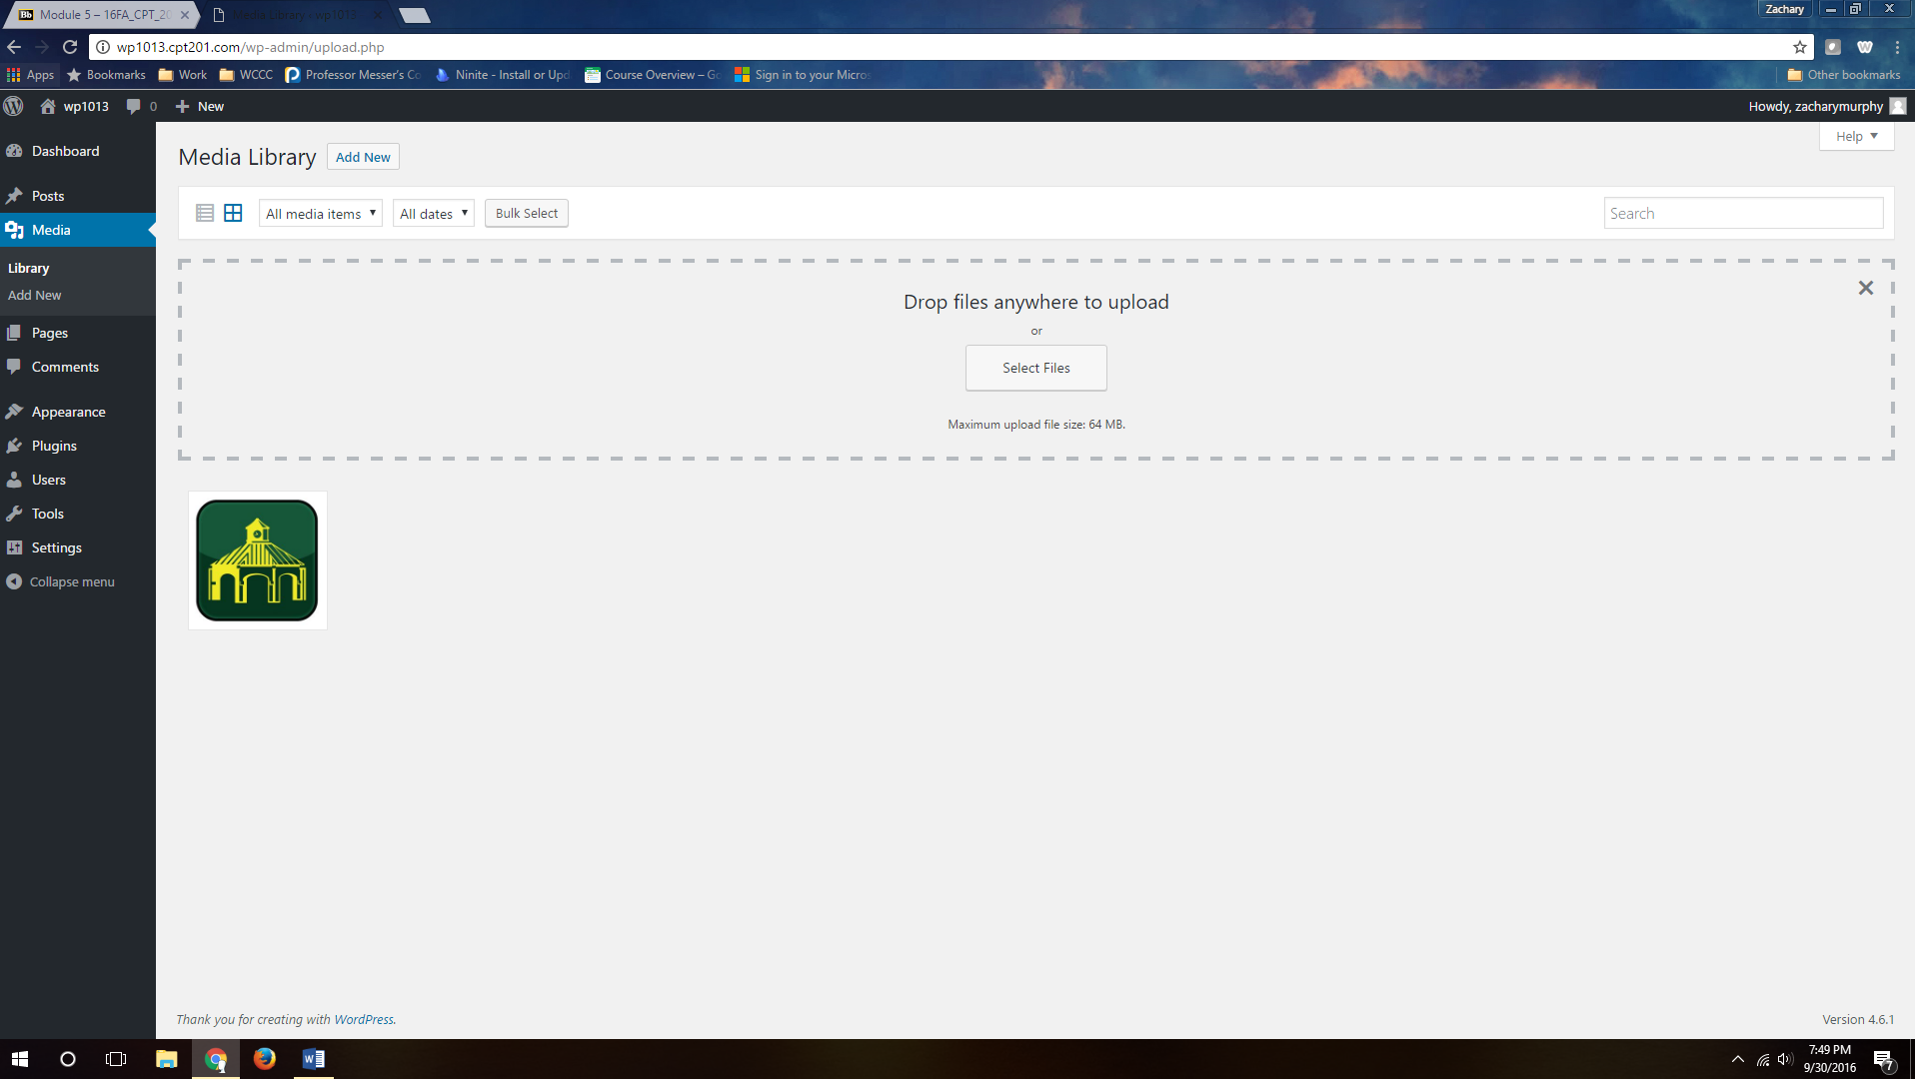

Once you add a media file you will see it listed in your media library. You can click on the item you just uploaded and you will find it provides more information about that item, such as the URL WordPress gives it.

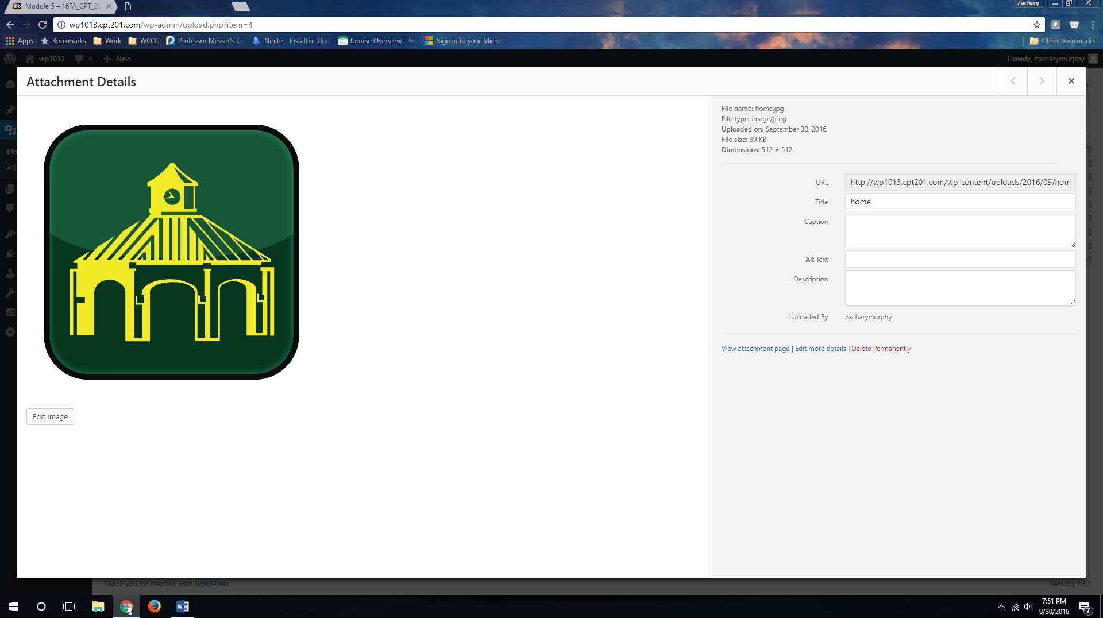

You can also give the media file a tile, caption, alternative text, or description. This is very similar to what you can do when coding HTML.

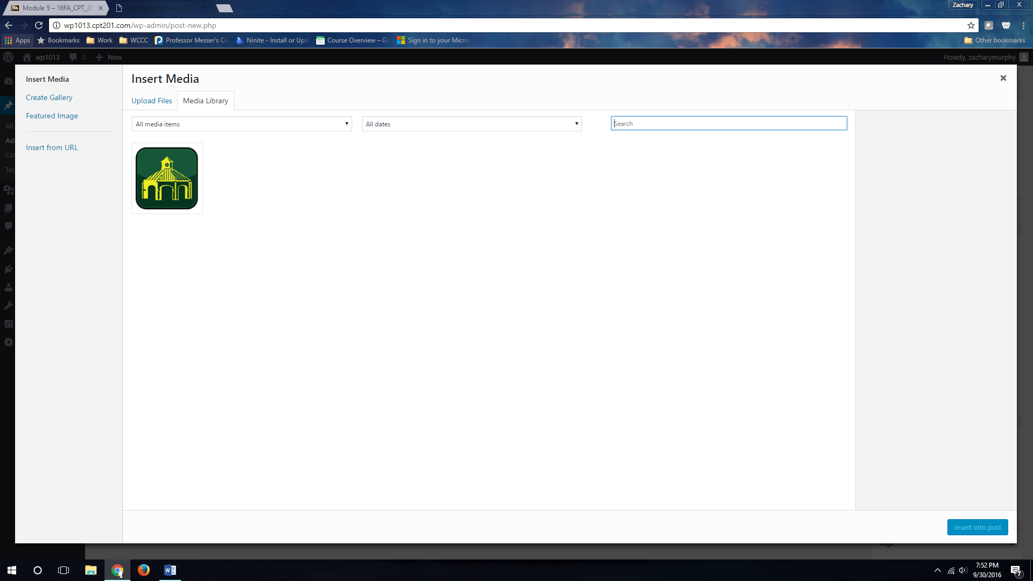

The benefit of using the media library is it stores the media on your account. So when you write a new posts or upload an image to a page, you can find it in your media gallery, even if it’s not saved on the computer you are using.

**What are the recommended settings?**

There are really no settings within this in particular Most of the settings would be made within the media files you upload and that would be up to you to determine what is best for your site.

**What are the subcategories?**



**How are the subcategories used?**

The Library category will store all your media files. While the Add New category allows you to add new media files both individually or bulk.

**Show others how to use the category and sub-category if needed?**

See screenshots.